**Bluewater Consulting Inc.**

# Relational Model (Physical Model)

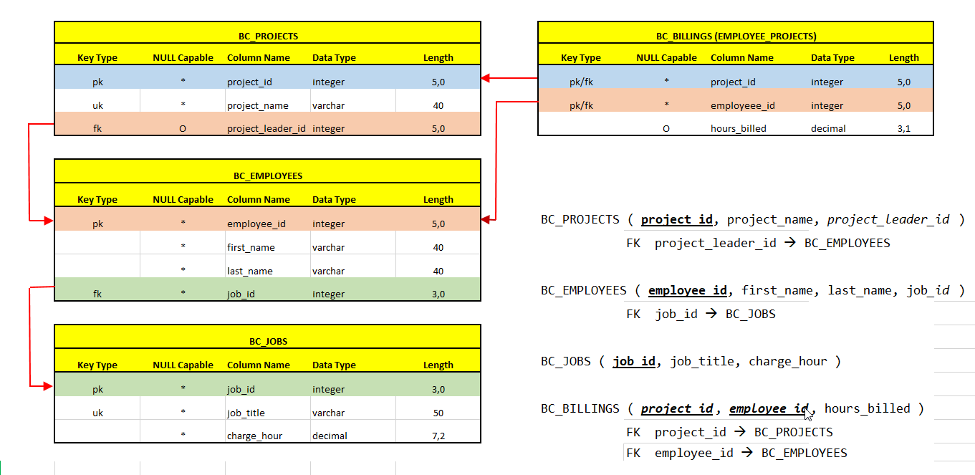

**INSERT Statements**

INSERT INTO bc_billings VALUES

INSERT INTO bc_employees VALUES

INSERT INTO bc_projects VALUES

(15, 'Lakeview',

(18, 'Web App',

(22, 'Blue Light',

(25, 'Power Lite',

105),

104),

NULL),

101);

(506, 'DDS Analyst', 45.95),

(507, 'Clerical Support', 26.87);

|  |  |  |  |
| --- | --- | --- | --- |
| (15, | 103, | 23.8), | (103, 'June', 'Arbough', 501), |
| (15, | 101, | 19.4), | (101, 'John', 'News', 502), |
| (15, | 105, | 35.7), | (105, 'Alice', 'Johnson', 502), |
| (15, | 106, | 12.6), | (106, 'William', 'Smith', 503), |
| (15, | 102, | 23.8), | (102, 'David', 'Senior', 504), |
| (18, | 114, | 25.6), | (114, 'Annelise', 'Jones', 503), |
| (18, | 118, | 45.3), | (118, 'James', 'Frommer', 505), |
| (18, | 104, | 32.4), | (104, 'Anne', 'Ramoras', 504), |
| (18, | 112, | 45.0), | (112, 'Darlene', 'Smithson', 506), |
| (22, | 105, | 65.7), | (113, 'Jen', 'Clarke', 503), |
| (22, | 104, | 48.4), | (111, 'Geoff', 'Wabash', 507), |
| (22, | 113, | 23.6), | (107, 'Maria', 'Alonzo', 503), |
| (22, | 111, | 22.0), | (115, 'Travis', 'Bawangi', 504), |
| (22, | 106, | 12.8), | (108, 'Ralph', 'Washington', 504); |
| (25, | 107, | 25.6), |  |
| (25, | 115, | 45.8), |  |
| (25, | 101, | 56.3), | INSERT INTO bc_jobs VALUES |
| (25, | 114, | 33.1), | (501, 'Lead Programmer', 85.50), |
| (25, | 108, | 23.6), | (502, 'Database Designer', 105.00), |
| (25, | 118, | 30.5), | (503, 'Programmer', 35.75), |
| (25, | 112, | 41.4); | (504, 'Systems Analyst', 96.75), |
|  |  |  | (505, 'General Support', 18.36), |